**ОТЧЁТ ПО ЛАБОРАТОРНОЙ РАБОТЕ № 4**

**Выполнил студент 3 курса МОиАИС**

**Сушин Андрей**

**RS-триггер**

Асинхронный RS триггер с прямыми входами (2 элемента ИЛИ-НЕ)

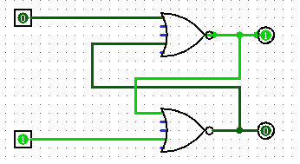

|  |  |  |  |
| --- | --- | --- | --- |
| **S** | **R** | **Q** | $$\overline{Q}$$ |
| 0 | 0 | $$Q_{i-1}$$ | $${\overline{Q}}_{i-1}$$ |
| 0 | 1 | 0 | 1 |
| 1 | 0 | 1 | 0 |
| 1 | 1 | 0 | 0 |

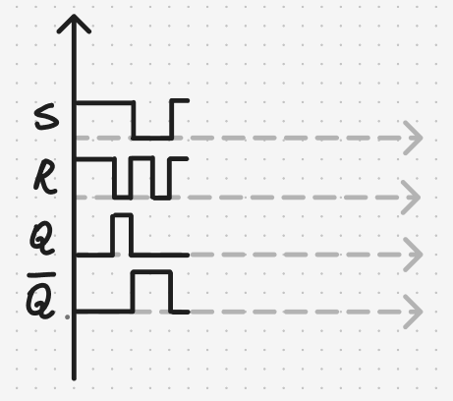

Асинхронный RS-триггер с инверсными входами (2 элемента И-НЕ)

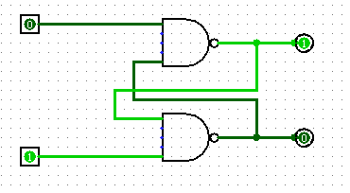

|  |  |  |  |
| --- | --- | --- | --- |
| **S** | **R** | **Q** | $$\overline{Q}$$ |
| 0 | 0 | $$0$$ | $$0$$ |
| 0 | 1 | 1 | 0 |
| 1 | 0 | 0 | 1 |
| 1 | 1 | $$Q_{i-1}$$ | $${\overline{Q}}_{i-1}$$ |

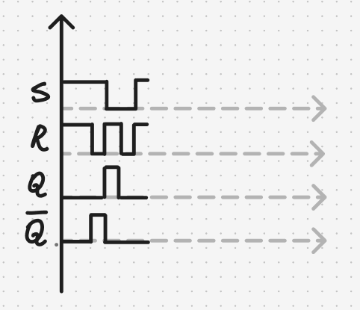

Синхронный RS-триггер

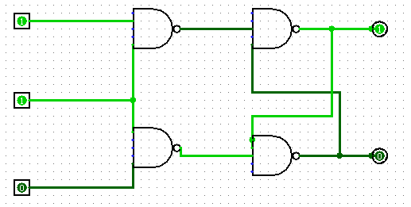

|  |  |  |  |  |
| --- | --- | --- | --- | --- |
| **S** | **R** | **С** | **Q** | $$\overline{Q}$$ |
| - | - | 0 | $$Q_{i-1}$$ | $${\overline{Q}}_{i-1}$$ |
| 0 | 0 | 1 | $$Q_{i-1}$$ | $${\overline{Q}}_{i-1}$$ |
| 0 | 1 | 1 | 0 | 1 |
| 1 | 0 | 1 | 1 | 0 |
| 1 | 1 | 1 | 0 | 0 |

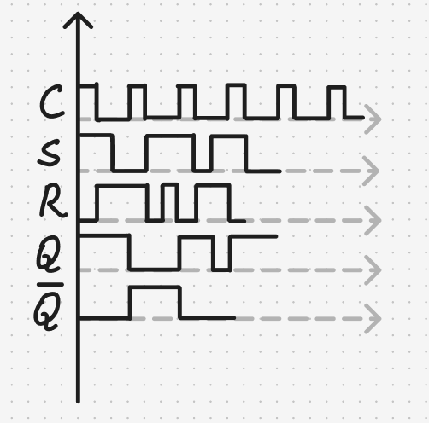

S-триггер

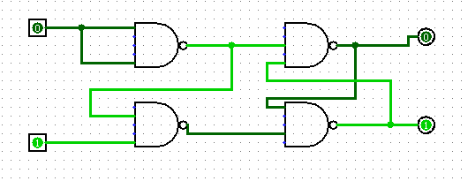

|  |  |  |  |
| --- | --- | --- | --- |
| **S** | **R** | **Q** | $$\overline{Q}$$ |
| 0 | 0 | $$Q_{i-1}$$ | $${\overline{Q}}_{i-1}$$ |
| 1 | 0 | 1 | 0 |
| 0 | 1 | 0 | 1 |
| 1 | 1 | 1 | 1 |

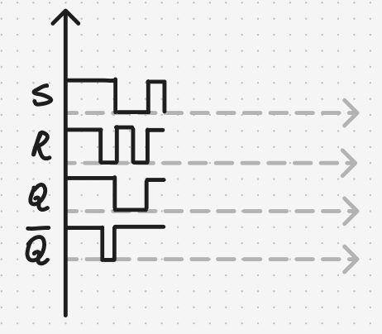

R-триггер

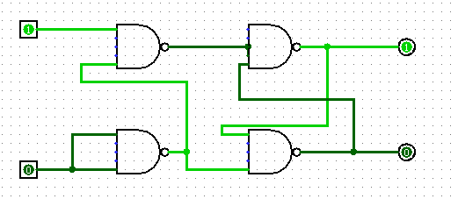

|  |  |  |  |
| --- | --- | --- | --- |
| **S** | **R** | **Q** | $$\overline{Q}$$ |
| 0 | 0 | $$Q_{i-1}$$ | $${\overline{Q}}_{i-1}$$ |
| 1 | 0 | 1 | 0 |
| 0 | 1 | 0 | 1 |
| 1 | 1 | 0 | 0 |

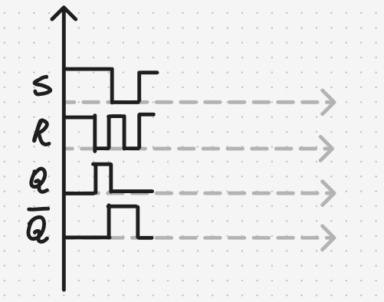

E-триггер

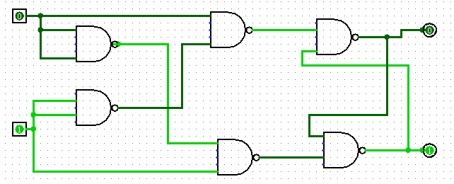

|  |  |  |  |
| --- | --- | --- | --- |
| **S** | **R** | **Q** | $$\overline{Q}$$ |
| 0 | 0 | $$Q_{i-1}$$ | $${\overline{Q}}_{i-1}$$ |
| 1 | 0 | 1 | 0 |
| 0 | 1 | 0 | 1 |
| 1 | 1 | $$Q_{i-1}$$ | $${\overline{Q}}_{i-1}$$ |

